create or replace procedure net_sal(p_id in empl.emp_id%TYPE) is

begin

update empl set con_pay=basic_pay*20/100 where emp_id=p_id;

update empl set net_sal=basic_pay+con_pay where emp_id=p_id;

end;

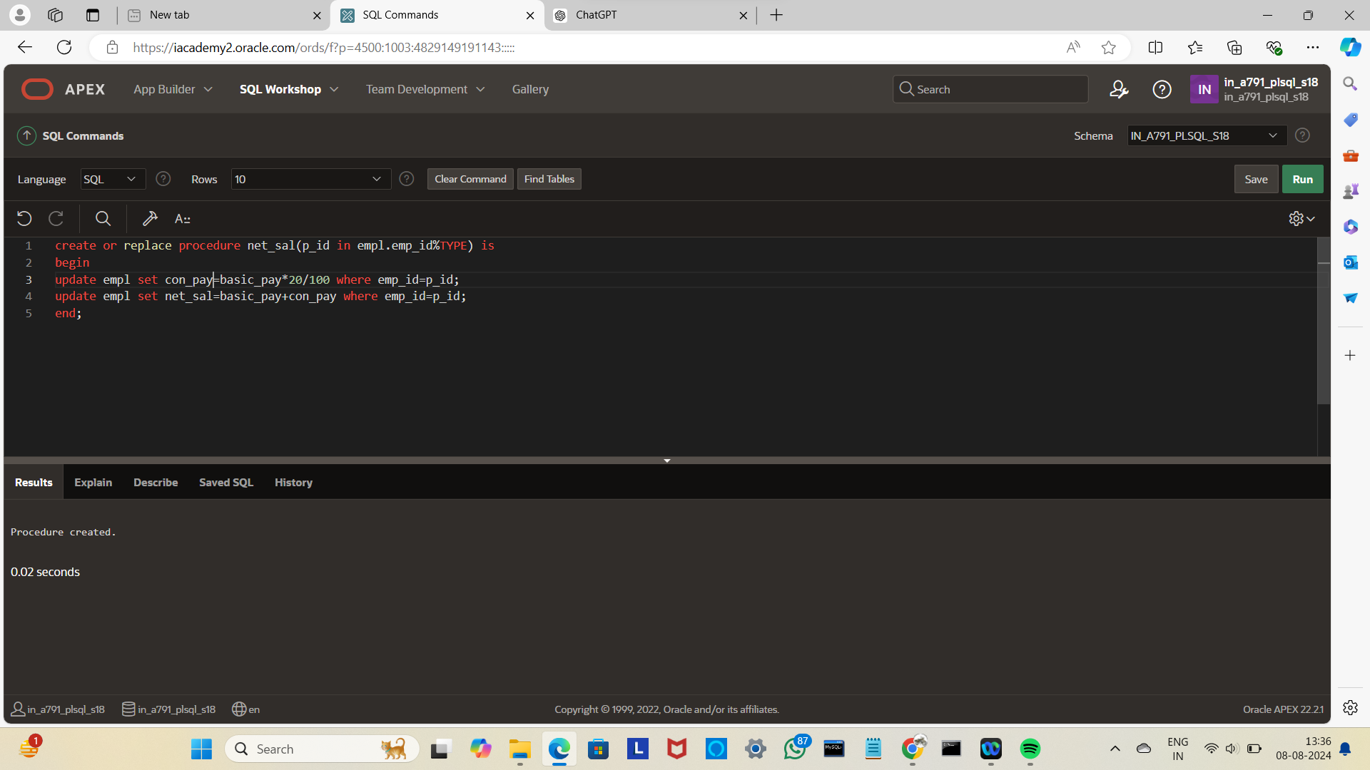

begin

net_sal(101);

end;

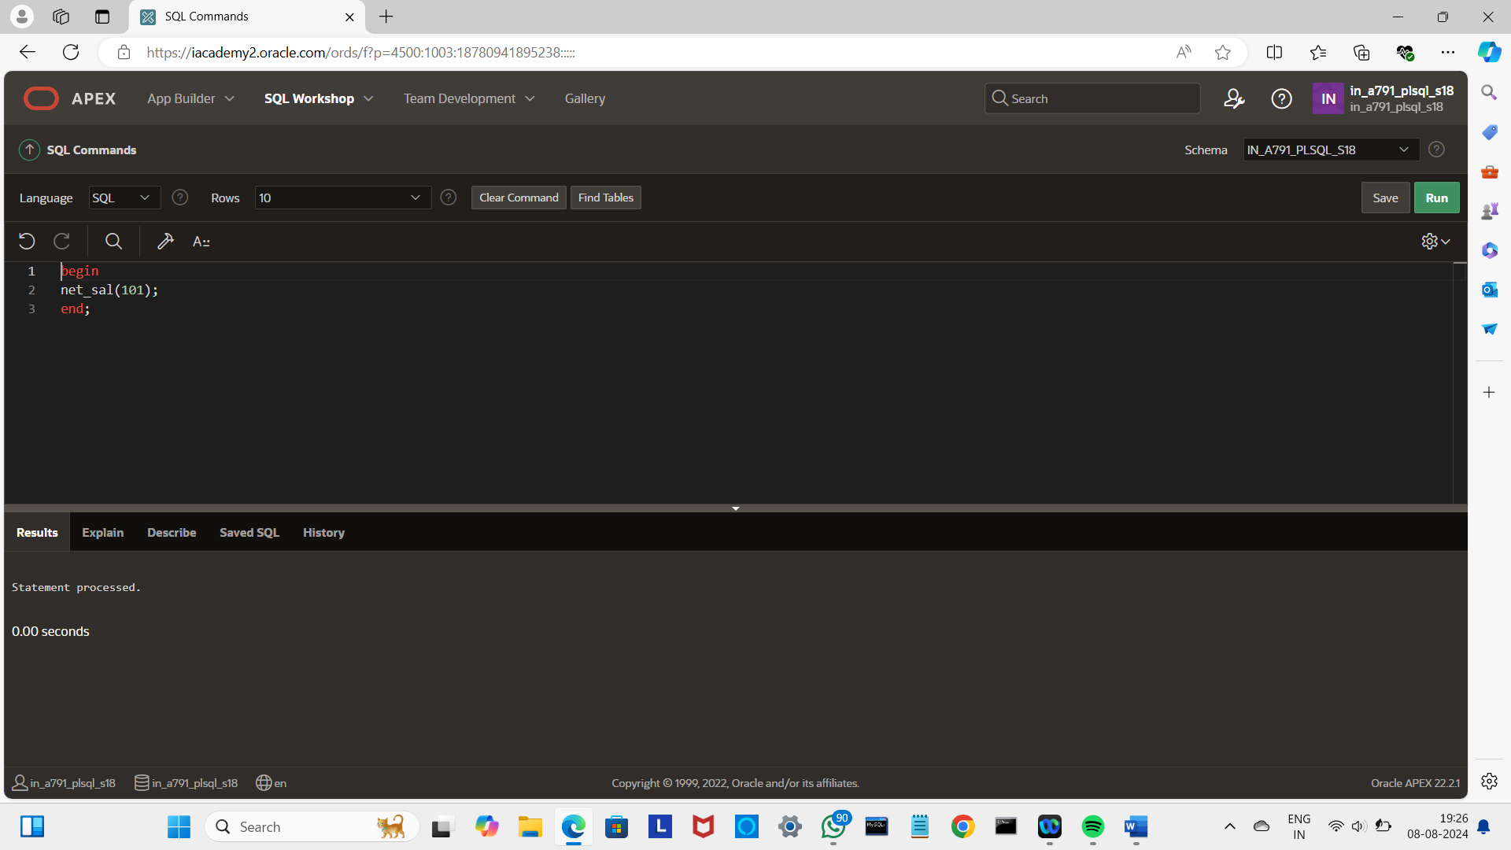

select*from empl;

